Information Retrieval
Practical Manual

Prepared By
Ms. Poornima Nadar Assistant Professor
Department of Computer Science

Course: Information Retrieval Programme: B.Sc. Computer Science
Semester: VI
Academic Year: 2025 – 2026

INDEX

Sr.No | Topics | Date | Signature
1 | Document Indexing and Retrieval  - Implement an inverted index construction algorithm.  - Build a simple document retrieval system using the constructed index.
2 | Retrieval Models  - Implement the Boolean retrieval model and process queries.  - Implement the vector space model with TF-IDF weighting and cosine similarity.
3 | Spelling Correction in IR Systems  - Develop a spelling correction module using edit distance algorithms.  - Integrate the spelling correction module into an information retrieval system
4 | Evaluation Metrics for IR Systems  - Calculate precision, recall, and F-measure for a given set of retrieval results.  - Use an evaluation toolkit to measure average precision and other evaluation metrics.
5 | Text Categorization  - Implement a text classification algorithm (e.g., Naive Bayes or Support Vector Machines).  - Train the classifier on a labelled dataset and evaluate its performance.
6 | Clustering for Information Retrieval  - Implement a clustering algorithm (e.g., K-means or hierarchical clustering).  - Apply the clustering algorithm to a set of documents and evaluate the clustering results.
7 | Web Crawling and Indexing  - Develop a web crawler to fetch and index web pages.  - Handle challenges such as robots.txt, dynamic content, and crawling delays.
8 | Link Analysis and PageRank  - Implement the PageRank algorithm to rank web pages based on link analysis.  - Apply the PageRank algorithm to a small web graph and analyze the results.

PRACTIAL 1
Aim: Document Indexing and Retrieval
A. Implement an inverted index construction algorithm. Build a simple document retrieval system using the constructed index.
Code:

import re
from collections import defaultdict

class DocumentRetrievalSystem: def init (self):
self.index = defaultdict(set) self.documents = {}

def tokenize(self, text):
return re.findall(r'\b\w+\b', text.lower())

def index_document(self, doc_id, text): tokens = self.tokenize(text)
for token in tokens: self.index[token].add(doc_id)
self.documents[doc_id] = text

def retrieve_documents(self, query): tokens = self.tokenize(query) relevant_doc_ids = set()

for token in tokens:
if token in self.index:
if not relevant_doc_ids: relevant_doc_ids.update(self.index[token])
else:
relevant_doc_ids.intersection_update(self.index[token])

return [(doc_id, self.documents[doc_id]) for doc_id in relevant_doc_ids]

# Example usage
doc_retrieval = DocumentRetrievalSystem() doc_retrieval.index_document(1, "This is the first Document") doc_retrieval.index_document(2, "This is the second Document") doc_retrieval.index_document(3, "Another document is here")

query = input("Enter your query: ")
results = doc_retrieval.retrieve_documents(query)

print("Query:", query)
for doc_id, text in results: print(f"Document {doc_id}: {text}")

Output:
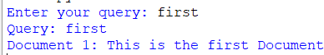

PRACTIAL 2
Aim: Retrieval Models
A. Implement the Boolean retrieval model and process queries. Implement the vector space model with TF-IDF weighting and cosine similarity.
Code:
import pandas as pd
from sklearn.feature_extraction.text import CountVectorizer

print("Demonstration of Boolean Retrieval Model using Bitwise operations on Term Document Incidence Matrix of a corpus")

# Corpus / Documents corpus = {
'this is the first document.',
'this document is the second document.', 'And this is the third one.',
'Is this the first document?'
}

print("\nThe corpus is:") print(corpus)

# Creating term-document matrix vectorizer = CountVectorizer()
x = vectorizer.fit_transform(corpus)

# Convert matrix to DataFrame
df = pd.DataFrame(x.toarray(), columns=vectorizer.get_feature_names_out()) print("\nThis generated DataFrame is:")
print(df)

# Query processing
print("\nQuery processing on the term-document incidence matrix:")

# 1. this AND first
print("\n1. Find all document ids for query: 'this AND first'") alldata = df[(df['this'] == 1) & (df['first'] == 1)]
print("Document ids where both 'this' and 'first' terms are present:", alldata.index.tolist())

# 2. this OR first
print("\n2. Find all document ids for query: 'this OR first'") ordata = df[(df['this'] == 1) | (df['first'] == 1)]
print("Document ids where either 'this' or 'first' terms are present:", ordata.index.tolist())

# 3. NOT and

print("\n3. Find all document ids for query: 'NOT and'") notdata = df[(df['and'] != 1)]
print("Document ids where 'and' term is not present:", notdata.index.tolist())

Output:
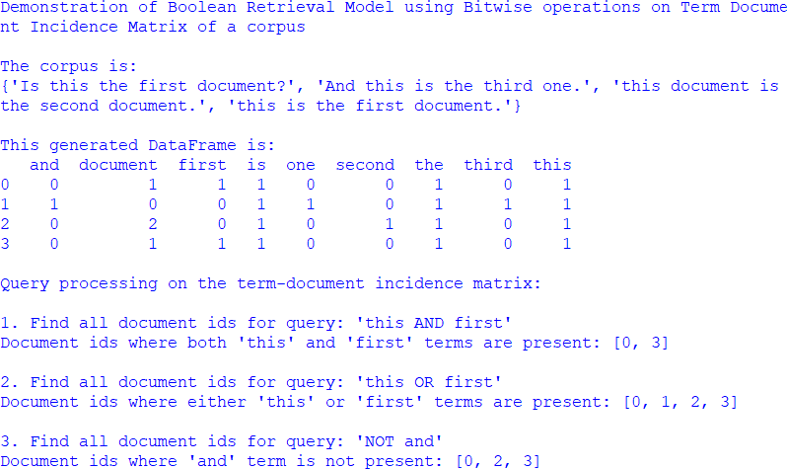

B. Implement the vector space model with TF-IDF weighting and cosine similarity.
Code:
# Practical 2b: Vector Space Model using TF-IDF and Cosine Similarity

from sklearn.feature_extraction.text import TfidfVectorizer from sklearn.metrics.pairwise import cosine_similarity

documents = [
"this is the first document",
"this document is the second document", "and this is the third one",
"is this the first document"
]

# Vectorize using TF-IDF tfidf_vectorizer = TfidfVectorizer()
tfidf_matrix = tfidf_vectorizer.fit_transform(documents)

print("TF-IDF Matrix:") print(tfidf_matrix.toarray())

# Example query similarity
query = ["this is the document"]
query_vector = tfidf_vectorizer.transform(query)

# Calculate cosine similarity
cos_sim = cosine_similarity(query_vector, tfidf_matrix)

print("\nCosine similarity scores for each document:") print(cos_sim)

Output:
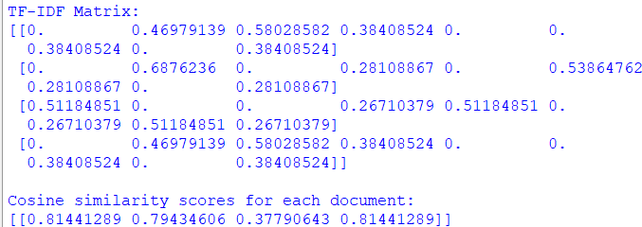

PRACTIAL 3
Aim: Spelling Correction in IR Systems
A. Develop a spelling correction module using edit distance algorithms. Integrate the spelling correction module into an information retrieval system
Code:
# Practical 3: Spelling Correction and Integration with IR System
#
Part A: Levenshtein Distance
def levenshtein_distance(str1, str2):
len_str1 = len(str1) + 1 len_str2 = len(str2) + 1

# Initialize matrix
matrix = [[0 for _ in range(len_str2)] for _ in range(len_str1)]

# Initialize first row and first column for i in range(len_str1):
matrix[i][0] = i
for j in range(len_str2): matrix[0][j] = j

# Fill the matrix
for i in range(1, len_str1):
for j in range(1, len_str2):
cost = 0 if str1[i-1] == str2[j-1] else 1 matrix[i][j] = min(
matrix[i-1][j] + 1, # Deletion matrix[i][j-1] + 1, # Insertion matrix[i-1][j-1] + cost # Substitution
)
return matrix[len_str1 - 1][len_str2 - 1] def suggest_correction(word, word_list):
# Compute distance for each word in dictionary
distances = [(w, levenshtein_distance(word, w)) for w in word_list]

# Sort by distance distances.sort(key=lambda x: x[1])

# Return the word with minimum distance return distances[0][0]
# ------------------ Part B: Integration with IR System ------------------ def retrieve_information(query, dictionary):

query_words = query.split()
corrected_words = [suggest_correction(word, dictionary) for word in query_words]
corrected_query = ' '.join(corrected_words) # Simulated retrieval stage
print(f"Retrieving information for corrected query: '{corrected_query}'")
#
Main Program
if name == " main ":

# Test for spelling correction (3a demonstration) input_word = "poonimo"
word_list = ["hello", "world", "python", "spell", "correct", "algorithm", "poornima", "poohnima"]

suggested_correction = suggest_correction(input_word, word_list) print(f"Suggested correction for '{input_word}': {suggested_correction}")
print("\n
\n")
# Demo for IR Integration (3b demonstration)
user_query = "speling correctin algorithm"
dictionary = ["spelling", "correction", "algorithm", "information", "retrieval", "system"]

retrieve_information(user_query, dictionary)

Output:

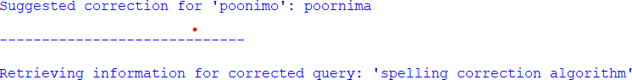

PRACTIAL 4
Aim: Evaluation Metrics for IR Systems
A. Calculate precision, recall, and F-measure for a given set of retrieval results.
Code:
# Practical 4a: Evaluation Metrics (Precision, Recall, F-measure)

def calculate_metrics(retrieved_set, relevant_set):
true_positive = len(retrieved_set.intersection(relevant_set)) false_positive = len(retrieved_set.difference(relevant_set)) false_negative = len(relevant_set.difference(retrieved_set))

print("True Positive:", true_positive) print("False Positive:", false_positive) print("False Negative:", false_negative)

precision = true_positive / (true_positive + false_positive) recall = true_positive / (true_positive + false_negative) f_measure = (2 * precision * recall) / (precision + recall)

return precision, recall, f_measure

# Example sets
retrieved_set = set(["doc1", "doc2", "doc3"]) relevant_set = set(["doc1", "doc4"])
precision, recall, f_measure = calculate_metrics(retrieved_set, relevant_set) print(f"Precision: {precision}")
print(f"Recall: {recall}")
print(f"F-measure: {f_measure}")

Output:
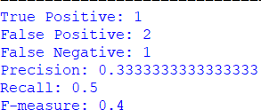

B. Use an evaluation toolkit to measure average precision and other evaluation metrics.
Code:
# Practical 4b: Evaluation using Toolkit (Average Precision Score) from sklearn.metrics import average_precision_score
# Ground truth relevance values y_true = [0, 1, 1, 0, 1, 1]

# System-generated scores / ranking scores y_scores = [0.1, 0.4, 0.35, 0.8, 0.65, 0.9]
average_precision = average_precision_score(y_true, y_scores) print(f"Average precision-recall score: {average_precision}")

Output:

PRACTIAL 5
Aim: Text Categorization
A. Implement a text classification algorithm (e.g., Naive Bayes or Support Vector Machines). Train the classifier on a labelled dataset and evaluate its performance.
Code:
# Practical-5: Text Categorization using Naive Bayes # Program: 5(a)

import numpy as np import re

class NaiveBayesClassifier: def init (self):
self.vocab = [] self.positive_counts = None self.negative_counts = None self.positive_prior = 0.0
self.negative_prior = 0.0

# Step 1: Preprocess text (tokenization + lowercase) def preprocess_review(self, review):
tokens = re.findall(r"\b\w+\b", review.lower()) return tokens

# Step 2: Convert text into a vector (Bag of Words) def vectorize_review(self, tokens):
vector = np.zeros(len(self.vocab)) for word in tokens:
if word in self.vocab: vector[self.vocab.index(word)] += 1
return vector

# Step 3: Train the classifier
def train(self, X_train, y_train): # Build vocabulary
for review in X_train:
tokens = self.preprocess_review(review) self.vocab.extend(tokens)
self.vocab = list(set(self.vocab))

# Initialize word counts
self.positive_counts = np.zeros(len(self.vocab)) self.negative_counts = np.zeros(len(self.vocab))

# Vectorize training data X_train_vectorized = [
self.vectorize_review(self.preprocess_review(review))

for review in X_train
]

positive_count = 0

# Count word frequencies per class
for i in range(len(X_train_vectorized)): if y_train[i] == 'positive':
self.positive_counts += X_train_vectorized[i] positive_count += 1
else:
self.negative_counts += X_train_vectorized[i]

# Calculate priors
self.positive_prior = positive_count / len(y_train) self.negative_prior = 1 - self.positive_prior

# Step 4: Predict class for test data def predict(self, X_test):
predictions = []
for review in X_test:
review_vectorized = self.vectorize_review( self.preprocess_review(review)
)

# Likelihood calculation positive_likelihood = np.prod(
(self.positive_counts / sum(self.positive_counts)) ** review_vectorized
) * self.positive_prior

negative_likelihood = np.prod(
(self.negative_counts / sum(self.negative_counts)) ** review_vectorized
) * self.negative_prior

if positive_likelihood > negative_likelihood: predictions.append('positive')
else:
predictions.append('negative') return predictions

# Training Data
positive_reviews = [
"The movie was amazing, I like great acting and an engaging plot."
]

negative_reviews = [
"Terrible! Would not recommend it to anyone."
]

X_train = positive_reviews + negative_reviews

y_train = ['positive'] * len(positive_reviews) + ['negative'] *
len(negative_reviews)
#
X_test = [
Testing Data
"The acting was superb!"
]

y_test = ['positive']
#
Model Execution
classifier = NaiveBayesClassifier()
classifier.train(X_train, y_train)

predictions = classifier.predict(X_test)
print("Predicted class for the new review:", predictions[0])

accuracy = sum(
1 for true_label, predicted_label in zip(y_test, predictions) if true_label == predicted_label
) / len(y_test)

print("Accuracy:", accuracy)

Output:

PRACTIAL 6
Aim: Clustering for Information Retrieval
A. Implement a clustering algorithm (e.g., K-means or hierarchical clustering). Apply the clustering algorithm to a set of documents and evaluate the clustering results.
Code:
import numpy as np
from sklearn.feature_extraction.text import TfidfVectorizer from sklearn.cluster import KMeans
from sklearn.metrics import silhouette_score

# Sample documents documents = [
"Machine learning is the study of computer algorithms that improve automatically through experience.",
"Deep learning is a subset of machine learning.",
"Natural language processing is a field of artificial intelligence.", "Computer vision is a field of study that enables computers to interpret
and understand the visual world.",
"Reinforcement learning is a type of machine learning algorithm that teaches an agent how to make decisions in an environment by rewarding desired behaviors.",
"Information retrieval is the process of obtaining information from a collection of documents.",
"Text mining is the process of deriving high-quality information from text.",
"Data clustering is the task of dividing a set of objects into groups.", "Hierarchical clustering builds a tree of clusters.",
"K-means clustering is a method of vector quantization."
]

# Convert documents into TF-IDF vectors vectorizer = TfidfVectorizer()
X = vectorizer.fit_transform(documents)

# Number of clusters k = 3

# Apply K-means clustering
kmeans = KMeans(n_clusters=k, random_state=42) kmeans.fit(X)

# Evaluate clustering using Silhouette Score silhouette_avg = silhouette_score(X, kmeans.labels_) print("Silhouette Score:", silhouette_avg)

# Print documents in each cluster for i in range(k):

cluster_docs_indices = np.where(kmeans.labels_ == i)[0] cluster_docs = [documents[idx] for idx in cluster_docs_indices] print(f"\nCluster {i+1}:")
for doc in cluster_docs: print("-", doc)

Output:
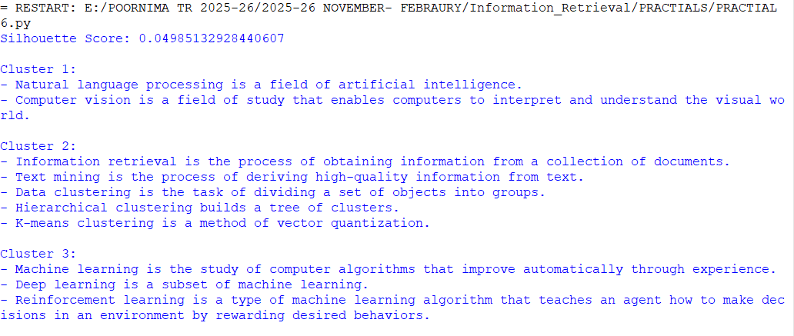

PRACTIAL 7
Aim: Web Crawling and Indexing
A. Develop a web crawler to fetch and index web pages. • Handle
challenges such as robots.txt, dynamic content, and crawling delays. Code:
import requests
from bs4 import BeautifulSoup import time
from urllib.parse import urlparse

class WebCrawler:
def init (self): self.visited_urls = set()

def crawl(self, url, depth=2, delay=1):
if depth == 0 or url in self.visited_urls: return

if not self.is_allowed_by_robots(url): print(f"Skipping {url} due to robots.txt rules") return

try:
response = requests.get(url) if response.status_code == 200:
soup = BeautifulSoup(response.text, 'html.parser') self.index_page(url, soup) self.visited_urls.add(url)

for link in soup.find_all('a'): new_url = link.get('href')
if new_url and new_url.startswith('http'): time.sleep(delay)
self.crawl(new_url, depth - 1, delay)

except Exception as e:
print(f"Error crawling {url}: {e}")

def is_allowed_by_robots(self, url): parsed = urlparse(url)
robots_url = f"{parsed.scheme}://{parsed.netloc}/robots.txt"

try:
response = requests.get(robots_url)
if response.status_code == 200 and "Disallow: /" in response.text: return False
except:
pass

return True

def index_page(self, url, soup):
title = soup.title.string if soup.title else "No title" paragraph = soup.find('p').get_text() if soup.find('p') else "No
paragraph found"

print(f"\nIndexing: {url}") print(f"Title: {title}")
print(f"First Paragraph: {paragraph}") print("-" * 40)

if name == " main ": crawler = WebCrawler()
crawler.crawl("https://www.example.com")

Output:
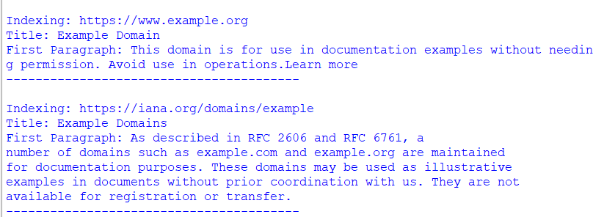

PRACTIAL 8
Aim: Link Analysis and PageRank
A. Implement the PageRank algorithm to rank web pages based on link analysis. Apply the PageRank algorithm to a small web graph and analyze the results.
Code:
def pagerank(graph, damping_factor=0.85, epsilon=1.0e-8, max_iterations=100): """
Compute the PageRank of nodes in the graph.

:param graph: Dictionary where keys are pages and values are lists of outgoing links
:param damping_factor: Probability of following a link
:param epsilon: Convergence threshold
:param max_iterations: Maximum iterations
:return: Dictionary of PageRank scores """

num_nodes = len(graph)

# Initialize PageRank scores
pagerank_scores = {node: 1.0 / num_nodes for node in graph}

for _ in range(max_iterations): new_pagerank_scores = {} max_diff = 0

for node in graph:
# Base PageRank value
new_pagerank = (1 - damping_factor) / num_nodes

# Add contributions from incoming links for referring_page, links in graph.items():
if node in links: num_outlinks = len(links) new_pagerank += (
damping_factor * pagerank_scores[referring_page] /
num_outlinks
)

new_pagerank_scores[node] = new_pagerank
diff = abs(new_pagerank - pagerank_scores[node]) max_diff = max(max_diff, diff)
pagerank_scores = new_pagerank_scores # Check convergence
if max_diff < epsilon:

break

return pagerank_scores web_graph = {
'A': ['B', 'C'],
'B': ['C'],
'C': ['A']
}
pagerank_scores = pagerank(web_graph)

sorted_scores = sorted( pagerank_scores.items(), key=lambda x: x[1], reverse=True
)

print("PageRank Scores:")
for node, score in sorted_scores: print(f"{node}: {score:.4f}")

Output:
